**Internship Documentation :**

**Company Name : Akash Technolab**

**Internship technology : PHP**

**Submitted By : Ronakbhai Bharatbhai Bhalala**

**Date : 25/05/21**

**Task 1: Create small Website in HTML using Table tag And Div Tag.**

Code:-

# index.html

<html>

<head>

<meta name="viewport" content="width=device-width, initial-scale=1.0">

<title>GECM :: Computer Engineering</title>

<link rel="shortcut icon" href="image\collegelogo.jpg">

<link rel="stylesheet" type="text/css" href="main.css">

</head>

<body>

<header>

<center>

<!--img src="image\department.jpeg"-->

<br><br><br><br><br><br>

<table > <tr><td><img src="image\collegelogo.jpg"></td><td>

<h1>Government Engineering College, Modasa</h1></td></tr></table></center></header><center>

<h2>Computer Engineering Department</h3></center>

<section><nav class="topnav"><ul class="navto">

<li><a class="active" href="indexmain.html"><b>About Department</b></a></li>

<li><a href="visionandmission.html">Vision & Mission</a></li>

<li><a href="http://syllabus.gtu.ac.in/">Syllabus</a></li>

<li><a href="faculty.html">Faculty</a></li>

<li><a href="C:\xampp\htdocs\gecm\index.html">Publications</a></li>

<li><a href="facilities.html">Facilities</a></li>

<li><a href="C:\xampp\htdocs\gecm\index.html">Department Academic Calender 2019-2020</a></li></ul>

<li><a href="faculty1.html">Contact Us</a></li>

</nav>

<div><!--This paragraph details about department -->

<h2 style=" margin-left:120px; margin-right:120px;" align="center"><strong>Welcome to GECM Computer Engineering Department !!! </strong></h2>

<hr style=" margin-left:120px; margin-right:120px;color:green;">

<center><img src="image\department.jpeg" class="style"></center>

<h2><center>--------About Department--------</h2></center>

<hr style=" margin-left:120px; margin-right:120px;">

<p style="margin-left:120px; margin-right:120px;"align="justify">This <strong>department</strong> is running from <b>2001</b>. The staff has developed required laboratories in the areas like <i>Computer Hardware, Computer Networking & Security, Database Management System, Computer Graphics and Internet Technology</i> in tune with real-time systems.</p>

<p style="margin-left:120px; margin-right:120px;" align="justify">The department has <em>various</em> laboratories in the area of Computer Hardware, Computer Networking and network security, Data Base management system, Computer Graphics and internet Technology in tune with the real-time system.</p>

<p style="margin-left:120px; margin-right:120px;" align="justify">The internet access is provided to the students to update their knowledge in the various fields.The campus-wide area network is managed through this department. The newly developed computer center for this department is equipped with more than 250 latest computer system connected with LAN and loaded with various softwares.</p>

<p style="margin-left:120px; margin-right:120px;"align="justify">The Department has purchased Latest Computer Servers and Network-based online teaching system software named Content Server. The department is sharing all infrastructural facilities of Information Technology Department. The laboratories in the department are well developed to cater needs of the students. Department is also offering Post Graduate course in Computer Science & Engineering since 2010.</p>

<p style="margin-left:120px; margin-right:120px;" align="justify">Computer Engineering and Information Technology department run in a newly constructed, well-furnished building. The main strength of the department is highly qualified and well-experienced faculties. Also, the department is well equipped with an ample number of computer systems, networking of more than 250 nodes and required software and hardware. Department has well equipped 10 computer laboratories and two seminar halls. Campus Wide Network of college is handled by the <cite> department </cite>with 30 Wi-Fi access points with 1 controller. It has High-End Servers available for various activities.</p>

<h2><center>--------About Course--------</h2></center>

<hr style=" margin-left:120px; margin-right:120px;color:green;">

<p style="margin-left:120px; margin-right:120px;"align="justify">Computer engineering blends together computer science and electrical engineering to further advancements in digital technology, computer networking, and computer systems. In turn, computer engineers use their extensive knowledge of hardware and software design and computer programming to make computing platforms and applications more efficient and effective. Seamlessly integrating the latest innovations, computer engineers develop new computer hardware, design and implement software applications, and enhance the capabilities of networks and communications systems.</p>

<p style="margin-left:120px; margin-right:120px;"align="justify">Computer engineers work with hardware and software, ensuring that the two are seamlessly integrated and functioning properly. Computer engineers focus on innovation—making computing systems safer, faster and more powerfull. At the career level, there are two main avenues: hardware and software engineering. Hardware engineers focus their skills on computer systems and components, designing microprocessors, circuit boards, routers and other embedded devices. On the software side, these engineers create, test and debug programs and applications that run on computers, mobile devices and more.</p>

</div>

</section>

<table border="1px solid" align="center" width="70%" id="tbl1">

<tr bgcolor="lightblue"><th colspan="5" >Under Graduate/Post Graduate Courses</th>

<tr >

<th align="left" >Name of Course</th>

<th style="text-align:center;">Type</th>

<th style="text-align:center;">Period (Years)</th>

<th style="text-align:center;">Intake</th>

<th style="text-align:center;">Year of Starting</th>

</tr>

<tr id="tbl1"align="center">

<td align="left">Computer Engineering</td>

<td>UG</td>

<td>4</td>

<td>120</td>

<td>2001</td>

</tr>

<tr id="tbl1"align="center">

<td align="left">Computer Engineering & technology</td>

<td>PG</td>

<td>2</td>

<td>18</td>

<td>2010</td>

</tr>

</table>

<div>

<h2><center>--------Facilities-------- </h2></center>

<hr style=" margin-left:120px; margin-right:120px;color:green;">

<div>

<table align="center" class="tabl1">

<tr>

<td colspan="2">Wi-Fi enabled Department</td>

<td>Campus Wide Fiber Optic Cable Network</td>

</tr>

<tr>

<td colspan="2"><ul type="arrow"><li>System Lab</li></ul></td>

<td>Network Lab</td>

</tr>

<tr>

<td colspan="2">Programming language Lab</td>

<td>DBMS Lab</td>

</tr>

<tr>

<td colspan="2">Digital Logic Lab</td>

<td>Operating System Lab</td>

</tr>

<tr>

<td colspan="2">Seminar Halls</td>

<td>Digital Learning Lab</td>

</tr>

</table>

</div>

</div>

<div class="footer1">

<div class="footer-content">

<div class="footer-section about">

<img style="height: 50px;" src="image\logo-footer.png">

<p>The mission of Government Engineering College, Modasa is to deliver technical programs and service to meet the changing need of society and industry and thereby contribute to the overall techno-economical development of the State in particular and national in general and improve quality of life of communities.</p>

</div>

<div class="footer-section links">

<table >

<th class="footer-table" align="left">Useful Links</th>

<tr ><td class="td2"><a href="https://www.gtu.ac.in/">GTU</a></td></tr>

<tr ><td class="td2"><a href="https://www.aicte-india.org">AICTE</a></td></tr>

<tr ><td class="td2"><a href="https://nptel.ac.in/">NPTEL</a></td></tr>

<tr ><td class="td2"><a href="https://www.jacpcldce.ac.in/">ACPC</a></td></tr>

<tr ><td class="td2"><a href="https://www.coursera.org/">COURSERA</a></td></tr>

</table>

</div>

<div class="footer-section downloads">

<table>

<th class="footer-table" align="left">Downloads</th>

<tr>

<td class="td2"><a href="#">CIRCULARS</a> </td>

<tr>

</tr>

<td class="td3"><a href="#">NOTICES</a></td>

<tr>

<td class="td3"><a href="#">ADVERTISEMENT</a></td>

</tr>

<tr>

<td class="td3"><a href="#">APPLICATION FORM</a></td>

</tr>

<tr>

<td class="td3"><a href="#">HOSTEL FORM</a> </td>

</tr>

<tr>

<td class="td3"><a href="#">INFORMATION BROCHURE</a></td>

</tr>

</table>

</div>

</div>

</div>

</body>

</html>

# main.css

img{

height: 150px; width: 160px;

}

.style {height:50%; width:50%;padding-top:10px;align:center}

header{

background-color: #F4F7F7; padding: 30px;

text-align: center;

}

footer{

background-color: #F4F7F7;

}

ul{

list-style-type: none; margin: 0;

padding: 0;

}

.topnav{

overflow: hidden;

background-color: #333; position: relative;

top: 0;

width: 100%;

}

.topnav a { float: left; color: white;

text-align: center; padding: 14px 35px; text-decoration: none; font-size: 17px;

}

.topnav a:hover { background-color: lightpink; color: black;

}

.topnav a.active { background-color: blue; color: white;

}

#tbl1

{

border: 1px solid blue; border-collapse: collapse;

}

.tabl1 tr td{

text-align: center; padding: 5px;

border-collapse: collapse; border: 1px solid blue;

}

.fa1{

float: left;

}

.footer1{

background: #F4F7F7; color: #3F3F3F; height: 400px;

margin-top: 50px;

}

.footer1 .footer-bottom{ background: #343a40; color: #686868; height: 50px;

width: 100%; text-align: center;

position: absolute; bottom: 0px;

left: 0px;

padding-top: 20px;

}

.footer1 .footer-content{ border: 1px solid #D0D0D0; height: 400px;

display: flex;

}

.footer1 .footer-content .footer-section{ flex: 1;

padding: 50px;/*

border: 1px solid white;*/

}

.footer1 .footer-content .footer-section .footer-table{ border-bottom: 5px;

font-size: 25px;

border-color: #47B4FF; border-bottom-style:solid; padding: 3px;

width: 200px;

}

.footer1 .footer-content .footer-section .td3{ border-bottom: 1px;

font-size: 15px;

border-bottom-style: solid; width: 100%;

padding-bottom: 10px;

}

.footer1 .footer-content .footer-section .td2{ border-bottom: 1px;

border-bottom-color: black; font-size: 15px;

border-bottom-style: solid; width: 100%;

padding-bottom: 10px; padding-top: 15px;

}

# OUTPUT:

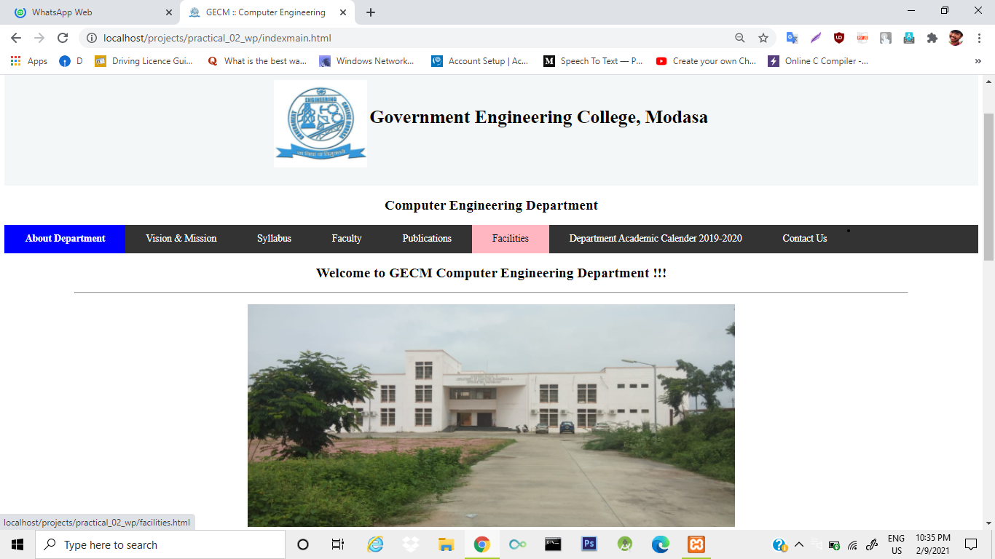

Figure:- 1.1.1. Homepage (About Department)

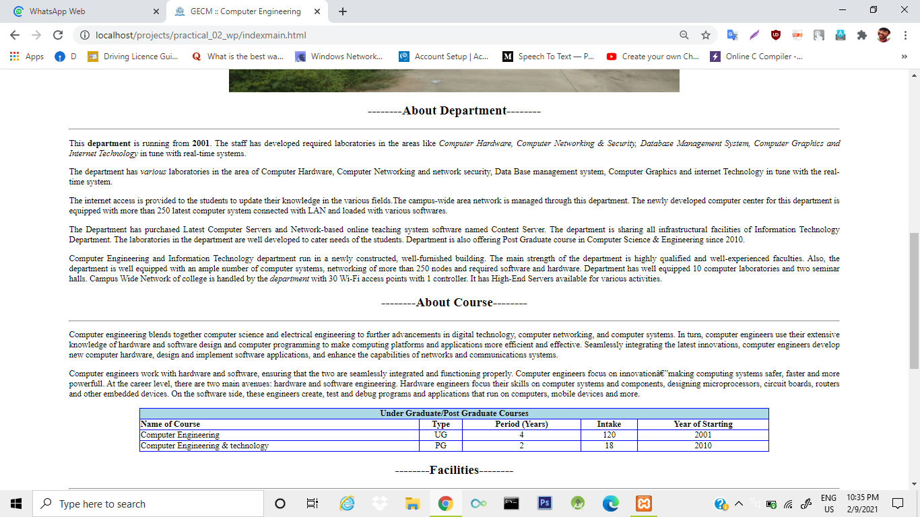

Figure:- 1.1.2. Homepage (About Department)

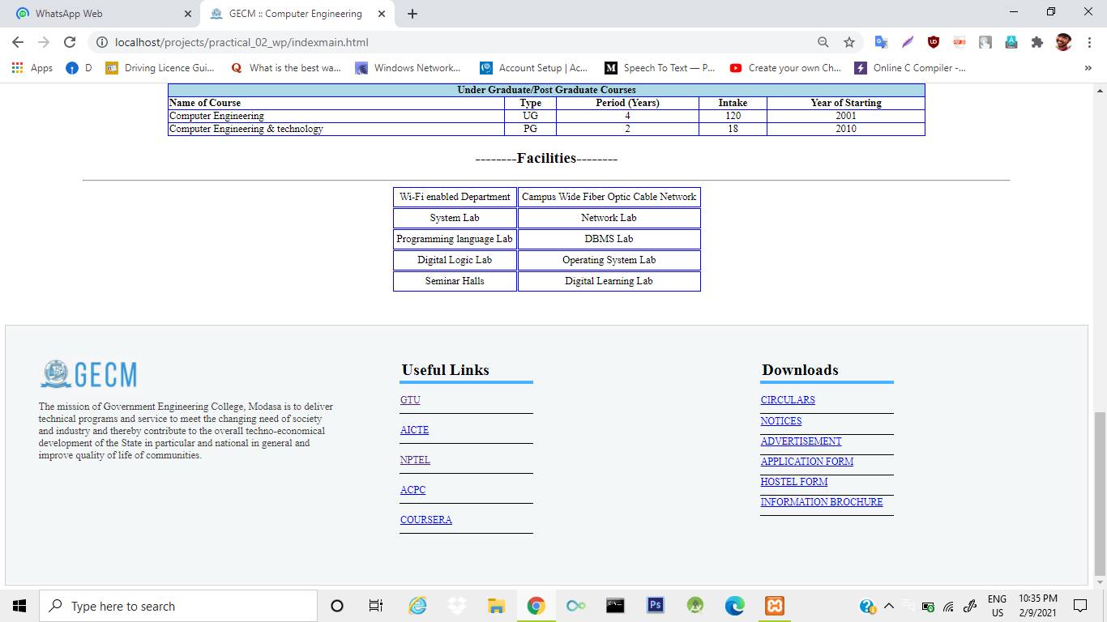

Figure:- 1.1.3. Homepage (About Department)

**Faculty.html**

<html>

<head>

<title>Computer :: Faculties</title>

<meta name="viewport" content="width=device-width, initial-scale=1.0">

<title>

GECM :: Computer Engineering

</title>

<link rel="shortcut icon" href="image\collegelogo.jpg">

<link rel="stylesheet" type="text/css" href="main.css">

<style type="text/css">

.imgtag{

padding: 20px; height: 200px; width: 150px;

}

.container{

height: 800px; width: 100%; position: relative;

}

.center{

width: 700px; height: 390px; border: 1px solid; border-color: blue; padding: 5px; margin-top: 20px;

}

.td1{

height: 400px; width: 500px;

}

td {

padding: 5px; border-bottom: 2px;

border-bottom-style: solid; border-bottom-color: #F0F0F0;

}

</style>

</head>

<body>

<header>

<center>

<table >

<tr>

<td style="border: none;">

<img src="image\collegelogo.jpg">

</td>

<td style="border: none;">

<h1>Government Engineering College, Modasa</h1>

</td>

</tr>

</table>

</center>

</header>

<center><h2>Computer Engineering Department</h3></center>

<section>

<nav class="topnav">

<ul class="navto">

<li><a href="indexmain.html">About Department</a></li>

<li><a href="visionandmission.html">Vision & mission</a></li>

<li><a href="C:\xampp\htdocs\gecm\index.html">Syllabus</a></li>

<li><a class="active" href="faculty.html"><b>Faculty</b></a></li>

<li><a href="C:\xampp\htdocs\gecm\index.html">Publications</a></li>

<li><a href="facilities.html">Facilities</a></li>

<li><a href="C:\xampp\htdocs\gecm\index.html">Department Academic Calendar 2019-2020</a></li>

<li><a href="faculty1.html">Contact Us</a></li>

</ul>

</nav>

<h1><center>Faculties</center></h1>

<hr style=" margin-left:120px; margin-right:120px;color:green;">

<br>

</section>

<div class="container">

<div align="center">

<!--faculty 1-->

<table class="center" >

<tr>

<td >

<img class="imgtag" src="image\ce_mbc.jpeg">

</td>

<td>

<h3 style="color: blue;">M B Chaudhari</h3>

<table >

<tr>

<tr>

<td>Designation</td>

<td>:Professor</td>

</tr>

<tr>

<td>Qualification</td>

<td>: ME COMPUTER ENGINEERING</td>

</tr>

<tr>

<td>Experience</td>

<td>: 28 Years</td>

</tr>

<tr>

<td>Date of joining</td>

<td>: 01-01-2009</td>

</tr>

<tr>

<td>Area of Interest</td>

<td>: Advanced Computing, Data Mining</td>

</tr>

<tr>

<td>Email</td>

<td>: hod_computer@gecmodasa.org

</tr>

<tr>

<td>Website</td>

<td>: <a href=" http://www.renruhak.org"> http://www.renruhak.org </a>

</tr>

</table>

</td>

</tr>

</table>

<!--faculty 3-->

<table class="center" >

<tr>

<td >

<img class="imgtag" src="image\JBB.jpg">

</td>

<td>

<h3 style="color: blue;">Jwalan Baria</h3>

<table >

<tr>

<tr>

<td>Designation</td>

<td>: ASSISTANT PROFESSOR </td>

</tr>

<tr>

<td>Qualification</td>

<td>: ME (CSE)</td>

</tr>

<tr>

<td>Experience</td>

<td>: 9years</td>

</tr>

<tr>

<td>Date of joining</td>

<td>: 07-10-2016</td>

</tr>

<tr>

<td>Area of Interest</td>

<td>: Web Development,<br>SOA,Web Services</td>

</tr>

<tr>

<td>Email</td>

<td>: jwalant.baria@gmail.com

</tr>

<tr>

<td>Website</td>

<td>: <a href=" https://jwalantbaria.in"> http://www.renruhak.org </a>

</tr>

</table>

</td>

</tr>

</table>

<!--faculty 1-->

<table class="center" >

<tr>

<td >

<img class="imgtag" src="image\CE_VM1.png">

</td>

<td>

<h3 style="color: blue;">Prof. Manisha Valera</h3>

<table >

<tr>

<tr>

<td>Designation</td>

<td>: ASSISTANT PROFESSOR </td>

</tr>

<tr>

<td>Qualification</td>

<td>: ME COMPUTER ENGINEERING</td>

</tr>

<tr>

<td>Experience</td>

<td>: 7 years</td>

</tr>

<tr>

<td>Date of joining</td>

<td>: 08-06-2020</td>

</tr>

<tr>

<td>Area of Interest</td>

<td>:Data Mining</td>

</tr>

<tr>

<td>Email</td>

<td>:valeramanisha@gmail.com

</tr>

<tr>

<td>Website</td>

<td>: <a href=" http://www.renruhak.org"> http://www.renruhak.org </a>

</tr>

</table>

</td>

</tr>

</table>

<div class="footer1">

<div class="footer-content">

<div class="footer-section about">

<img style="height: 50px; align:left;" src="image\logo-footer.png">

<p>The mission of Government Engineering College, Modasa is to deliver technical programs and service to meet the changing need of society and industry and thereby contribute to the overall techno-economical development of the State in particular and national in general and improve quality of life of communities.</p>

</div>

<div class="footer-section links">

<table >

<th class="footer-table" align="left">Useful Links</th>

<tr ><td class="td2"><a href="https://www.gtu.ac.in/">GTU</a></td></tr>

<tr ><td class="td2"><a href="https://www.aicte-india.org">AICTE</a></td></tr>

<tr ><td class="td2"><a href="https://nptel.ac.in/">NPTEL</a></td></tr>

<tr ><td class="td2"><a href="https://www.jacpcldce.ac.in/">ACPC</a></td></tr>

<tr ><td class="td2"><a href="https://www.coursera.org/">COURSERA</a></td></tr>

</table>

</div>

<div class="footer-section downloads">

<table>

<th class="footer-table" align="left">Downloads</th>

<tr>

<td class="td2"><a href="#">CIRCULARS</a> </td>

<tr>

</tr>

<td class="td3"><a href="#">NOTICES</a></td>

<tr>

<td class="td3"><a href="#">ADVERTISEMENT</a></td>

</tr>

<tr>

<td class="td3"><a href="#">APPLICATION FORM</a></td>

</tr>

<tr>

<td class="td3"><a href="#">HOSTEL FORM</a> </td>

</tr>

<tr>

<td class="td3"><a href="#">INFORMATION BROCHURE</a></td>

</tr>

</table>

</div>

</div>

</div>

</body>

</html>

<!--http://syllabus.gtu.ac.in/-->

# OUTPUT:-

# 

(Figure :- 1.2.1 Faculties Detail)

# 

# 

# (Figure :- 1.2.2 Faculties Detail)

# 

# (Figure :- 1.2.3 Faculties Detail)

**Facilities.html**

<html>

<head>

<meta name="viewport" content="width=device-width, initial-scale=1.0">

<title>GECM :: Computer Engineering</title>

<link rel="shortcut icon" href="image\collegelogo.jpg">

<link rel="stylesheet" type="text/css" href="main.css">

<style type="text/css">

.imgtag{

padding: 20px; height: 300px; width: 200px;

}

.smlb{

border-bottom: 1px;

border-bottom-color: black; width: 100%;

border-bottom-style: solid; padding-left: 25px}

.slab1{

border-bottom: 5px; border-bottom-color: red; border-bottom-style: solid; padding: 4px;

margin-top: 25px;

}

.table1{

margin-left:120px;

max-width:100px;

}

.table2{

width: 100%

}

.tbldiv1{

border-bottom: 1px; border-bottom-style: solid;

border-bottom-color: #F2F2F2;

margin-left:120px; margin-right:120px;

}

</style>

</head>

<body>

<header>

<center>

<!--img src="image\department.jpeg"-->

<br><br><br><br><br><br>

<table > <tr><td><img src="image\collegelogo.jpg"></td><td>

<h1>Government Engineering College, Modasa</h1></td></tr></table></center></header><center>

<h2>Computer Engineering Department</h3></center>

<section><nav class="topnav"><ul class="navto">

<li><a href="indexmain.html"><b>About Department</b></a></li>

<li><a href="visionandmission.html">Vision & mission</a></li>

<li><a href="http://syllabus.gtu.ac.in/">Syllabus</a></li>

<li><a href="faculty.html">Faculty</a></li>

<li><a href="C:\xampp\htdocs\gecm\index.html">Publications</a></li>

<li><a class="active" href="C:\xampp\htdocs\gecm\facilities.html">Facilities</a></li>

<li><a href="C:\xampp\htdocs\gecm\index.html">Department Academic Calender 2019-2020</a></li></ul>

<li><a href="faculty1.html">Contact Us</a></li></nav></nav>

<h1><center>Facilities</center></h1>

<hr style=" margin-left:120px; margin-right:120px;color:green;"><br>

</section>

<div class="navbar1">

<div class="slab1 topnav" >

<ul>

<li><a href="facilities.html" class="navto">Laboratories</a></li>

<li><a href="seminar.html">Seminar Room</a></li>

<li><a href="server.html">Server Room</a></li>

</ul>

</div>

<div>

<p style="margin-left:120px; margin-right:120px;"> There are total 10 laboratories in the department for performing practical in various domains like Computer Programming, Computer Graphics, Networking, Database Management, Operating Systems, Artificial Intelligence, etc. Department has a separate laboratory for computer hardware subjects.</p>

</div>

<div class="tbldiv1">

<table height="200px" class="table2" >

<tr>

<td class="table1"><b>8112 Project Lab</b></br></br>

<p>This lab is dedicatedly used for project and design engineering. Sufficient number of PC, laptop points and other required infrastructure is available in this lab.</p></br></br>

</td>

<td class="table1" align="center"><img class=".imgtag"src="image\8115_2.jpg">

</td>

</tr>

</table>

</div>

<div class="tbldiv1">

<table height="200px" class="table2">

<tr >

<td class="table1" align="center"><img src="image\8112_2.jpg"></td>

<td class="table1"><b>8113 Programming Lab - 1</b></br></br>

This lab is dedicatedly used for subjects such as DBMS, OS, CG, CoS, SE, Compiler Design and Python</td>

</tr>

</table>

</div>

<div class="tbldiv1">

<table height="200px" class="table2">

<tr>

<td class="table1"><b>8115 Hardware Lab</b></br></br>

This lab is dedicatedly used for hardware related subjects such as digital fundamentals, COA, CN, SoC and IoT.</br></br>

<td class="table1" align="center"><img src="image\8113_2.jpg">

</td>

</tr>

</table>

</div>

<div class="footer1">

<div class="footer-content">

<div class="footer-section about">

<img style="height: 50px;" src="image\logo-footer.png">

<p>The mission of Government Engineering College, Modasa is to deliver technical programs and service to meet the changing need of society and industry and thereby contribute to the overall techno-economical development of the State in particular and national in general and improve quality of life of communities.</p>

</div>

<div class="footer-section links">

<table >

<th class="footer-table" align="left">Useful Links</th>

<tr ><td class="td2"><a href="https://www.gtu.ac.in/">GTU</a></td></tr>

<tr ><td class="td2"><a href="https://www.aicte-india.org">AICTE</a></td></tr>

<tr ><td class="td2"><a href="https://nptel.ac.in/">NPTEL</a></td></tr>

<tr ><td class="td2"><a href="https://www.jacpcldce.ac.in/">ACPC</a></td></tr>

<tr ><td class="td2"><a href="https://www.coursera.org/">COURSERA</a></td></tr>

</table>

</div>

<div class="footer-section downloads">

<table>

<th class="footer-table" align="left">Downloads</th>

<tr>

<td class="td2"><a href="#">CIRCULARS</a> </td>

<tr>

</tr>

<td class="td3"><a href="#">NOTICES</a></td>

<tr>

<td class="td3"><a href="#">ADVERTISEMENT</a></td>

</tr>

<tr>

<td class="td3"><a href="#">APPLICATION FORM</a></td>

</tr>

<tr>

<td class="td3"><a href="#">HOSTEL FORM</a> </td>

</tr>

<tr>

<td class="td3"><a href="#">INFORMATION BROCHURE</a></td>

</tr>

</table>

</div>

</div>

</div>

</body>

</html>

**seminar.html**

<html>

<head>

<meta name="viewport" content="width=device-width, initial-scale=1.0">

<title>GECM :: Computer Engineering</title>

<link rel="shortcut icon" href="image\collegelogo.jpg">

<link rel="stylesheet" type="text/css" href="main.css">

</head>

<body>

<header>

<center>

<!--img src="image\department.jpeg"-->

<br><br><br><br><br><br>

<table > <tr><td><img src="image\collegelogo.jpg"></td><td>

<h1>Government Engineering College, Modasa</h1></td></tr></table></center></header><center>

<h2>Computer Engineering Department</h3></center>

<section><nav class="topnav"><ul class="navto">

<li><a href="indexmain.html"><b>About Department</b></a></li>

<li><a href="visionandmission.html">Vision & mission</a></li>

<li><a href="http://syllabus.gtu.ac.in/">Syllabus</a></li>

<li><a href="faculty.html">Faculty</a></li>

<li><a href="C:\xampp\htdocs\gecm\index.html">Publications</a></li>

<li><a class="active" href="C:\xampp\htdocs\gecm\facilities.html">Facilities</a></li>

<li><a href="C:\xampp\htdocs\gecm\index.html">Department Academic Calender 2019-2020</a></li></ul>

<li><a href="faculty1.html">Contact Us</a></li></nav></nav>

<h1><center>Facilities</center></h1>

<hr style=" margin-left:120px; margin-right:120px;color:green;"><br>

</section>

<div class="navbar1">

<div class="slab1 topnav" >

<ul>

<li><a href="facilities.html" class="navto">Laboratories</a></li>

<li><a href="seminar.html">Seminar Room</a></li>

<li><a href="server.html">Server Room</a></li>

</ul>

</div>

<div>

<h2><center><b>--------Seminar Room--------</b></h2></center>

<hr style=" margin-left:120px; margin-right:120px;color:green;">

<center><img src="image\seminar.jpg" class="style"></center>

<p style="margin-left:120px; margin-right:120px;">The Seminar Room is a space that seats up to around 120 people. Featuring a large whiteboard, 2 medium-sized tables, a podium, and a projector and small speaker set (in the media closet), fully air-conditioned, the Seminar Room is the ideal location for a guest lecture, a meeting, or a conference. The seminar room is one of the state-of-art facility in the college. It is equipped with the audio system and projection facilities. Lectures of prominent people, seminars and discussions are organized here. The hall is often used for Debates, Seminars, Council meeting and society’s events etc.

<br><br><b>Seminar Room-1 No.: 8119 (Ground Floor)</b></p>

</div>

<div class="footer1">

<div class="footer-content">

<div class="footer-section about">

<img style="height: 50px;" src="image\logo-footer.png">

<p>The mission of Government Engineering College, Modasa is to deliver technical programs and service to meet the changing need of society and industry and thereby contribute to the overall techno-economical development of the State in particular and national in general and improve quality of life of communities.</p>

</div>

<div class="footer-section links">

<table >

<th class="footer-table" align="left">Useful Links</th>

<tr ><td class="td2"><a href="https://www.gtu.ac.in/">GTU</a></td></tr>

<tr ><td class="td2"><a href="https://www.aicte-india.org">AICTE</a></td></tr>

<tr ><td class="td2"><a href="https://nptel.ac.in/">NPTEL</a></td></tr>

<tr ><td class="td2"><a href="https://www.jacpcldce.ac.in/">ACPC</a></td></tr>

<tr ><td class="td2"><a href="https://www.coursera.org/">COURSERA</a></td></tr>

</table>

</div>

<div class="footer-section downloads">

<table>

<th class="footer-table" align="left">Downloads</th>

<tr>

<td class="td2"><a href="#">CIRCULARS</a> </td>

<tr>

</tr>

<td class="td3"><a href="#">NOTICES</a></td>

<tr>

<td class="td3"><a href="#">ADVERTISEMENT</a></td>

</tr>

<tr>

<td class="td3"><a href="#">APPLICATION FORM</a></td>

</tr>

<tr>

<td class="td3"><a href="#">HOSTEL FORM</a> </td>

</tr>

<tr>

<td class="td3"><a href="#">INFORMATION BROCHURE</a></td>

</tr>

</table>

</div>

</div>

</div>

</body>

</html>

**server.html**

<html>

<head>

<meta name="viewport" content="width=device-width, initial-scale=1.0">

<title>GECM :: Computer Engineering</title>

<link rel="shortcut icon" href="image\collegelogo.jpg">

<link rel="stylesheet" type="text/css" href="main.css">

</head>

<body>

<header>

<center>

<!--img src="image\department.jpeg"-->

<br><br><br><br><br><br>

<table > <tr><td><img src="image\collegelogo.jpg"></td><td>

<h1>Government Engineering College, Modasa</h1></td></tr></table></center></header><center>

<h2>Computer Engineering Department</h3></center>

<section><nav class="topnav"><ul class="navto">

<li><a href="indexmain.html"><b>About Department</b></a></li>

<li><a href="visionandmission.html">Vision & mission</a></li>

<li><a href="http://syllabus.gtu.ac.in/">Syllabus</a></li>

<li><a href="faculty.html">Faculty</a></li>

<li><a href="C:\xampp\htdocs\gecm\index.html">Publications</a></li>

<li><a class="active" href="C:\xampp\htdocs\gecm\facilities.html">Facilities</a></li>

<li><a href="C:\xampp\htdocs\gecm\index.html">Department Academic Calender 2019-2020</a></li></ul>

<li><a href="faculty1.html">Contact Us</a></li></nav></nav>

<h1><center>Facilities</center></h1>

<hr style=" margin-left:120px; margin-right:120px;color:green;"><br><br>

</section>

<div class="navbar1">

<div class="slab1 topnav" >

<ul>

<li><a href="facilities.html" class="navto">Laboratories</a></li>

<li><a href="seminar.html">Seminar Room</a></li>

<li><a href="server.html">Server Room</a></li>

</ul>

</div>

<div>

<h2><center><b>--------Server Room--------</b></h2></center>

<hr style=" margin-left:120px; margin-right:120px;color:green;">

<center><img src="image\server_room.bmp" class="style"></center>

<p style="margin-left:120px; margin-right:120px;">The department maintains campus wide networking and INTERNET facility of institute. The INTERNET line is provided by NKN (National Knowledge Network) with speed up to 100 MBPS. Server room contains two high end servers, routers, Fortinet firewall system, switches and Wi-Fi controller.

<br><br><b>Server Room No.: 8103 (Ground Floor)</b></p>

</div>

<div class="footer1">

<div class="footer-content">

<div class="footer-section about">

<img style="height: 50px;" src="image\logo-footer.png">

<p>The mission of Government Engineering College, Modasa is to deliver technical programs and service to meet the changing need of society and industry and thereby contribute to the overall techno-economical development of the State in particular and national in general and improve quality of life of communities.</p>

</div>

<div class="footer-section links">

<table >

<th class="footer-table" align="left">Useful Links</th>

<tr ><td class="td2"><a href="https://www.gtu.ac.in/">GTU</a></td></tr>

<tr ><td class="td2"><a href="https://www.aicte-india.org">AICTE</a></td></tr>

<tr ><td class="td2"><a href="https://nptel.ac.in/">NPTEL</a></td></tr>

<tr ><td class="td2"><a href="https://www.jacpcldce.ac.in/">ACPC</a></td></tr>

<tr ><td class="td2"><a href="https://www.coursera.org/">COURSERA</a></td></tr>

</table>

</div>

<div class="footer-section downloads">

<table>

<th class="footer-table" align="left">Downloads</th>

<tr>

<td class="td2"><a href="#">CIRCULARS</a> </td>

<tr>

</tr>

<td class="td3"><a href="#">NOTICES</a></td>

<tr>

<td class="td3"><a href="#">ADVERTISEMENT</a></td>

</tr>

<tr>

<td class="td3"><a href="#">APPLICATION FORM</a></td>

</tr>

<tr>

<td class="td3"><a href="#">HOSTEL FORM</a> </td>

</tr>

<tr>

<td class="td3"><a href="#">INFORMATION BROCHURE</a></td>

</tr>

</table>

</div>

</div>

</div>

</body>

</html>

# OUTPUT:-

# 

(Figure :- 2.3.1 Facilities page)

# 

(Figure :- 2.3.1 Facilities page)

**seminar.html**

<html>

<head>

<meta name="viewport" content="width=device-width, initial-scale=1.0">

<title>GECM :: Computer Engineering</title>

<link rel="shortcut icon" href="image\collegelogo.jpg">

<link rel="stylesheet" type="text/css" href="main.css">

</head>

<body>

<header>

<center>

<!--img src="image\department.jpeg"-->

<br><br><br><br><br><br>

<table > <tr><td><img src="image\collegelogo.jpg"></td><td>

<h1>Government Engineering College, Modasa</h1></td></tr></table></center></header><center>

<h2>Computer Engineering Department</h3></center>

<section><nav class="topnav"><ul class="navto">

<li><a href="indexmain.html"><b>About Department</b></a></li>

<li><a href="visionandmission.html">Vision & mission</a></li>

<li><a href="http://syllabus.gtu.ac.in/">Syllabus</a></li>

<li><a href="faculty.html">Faculty</a></li>

<li><a href="C:\xampp\htdocs\gecm\index.html">Publications</a></li>

<li><a class="active" href="C:\xampp\htdocs\gecm\facilities.html">Facilities</a></li>

<li><a href="C:\xampp\htdocs\gecm\index.html">Department Academic Calender 2019-2020</a></li></ul>

<li><a href="faculty1.html">Contact Us</a></li></nav></nav>

<h1><center>Facilities</center></h1>

<hr style=" margin-left:120px; margin-right:120px;color:green;"><br>

</section>

<div class="navbar1">

<div class="slab1 topnav" >

<ul>

<li><a href="facilities.html" class="navto">Laboratories</a></li>

<li class="active"><a href="seminar.html">Seminar Room</a></li>

<li><a href="server.html">Server Room</a></li>

</ul>

</div>

<div>

<h2><center><b>--------Seminar Room--------</b></h2></center>

<hr style=" margin-left:120px; margin-right:120px;color:green;">

<center><img src="image\seminar.jpg" class="style"></center>

<p style="margin-left:120px; margin-right:120px;">The Seminar Room is a space that seats up to around 120 people. Featuring a large whiteboard, 2 medium-sized tables, a podium, and a projector and small speaker set (in the media closet), fully air-conditioned, the Seminar Room is the ideal location for a guest lecture, a meeting, or a conference. The seminar room is one of the state-of-art facility in the college. It is equipped with the audio system and projection facilities. Lectures of prominent people, seminars and discussions are organized here. The hall is often used for Debates, Seminars, Council meeting and society’s events etc.

<br><br><b>Seminar Room-1 No.: 8119 (Ground Floor)</b></p>

</div>

<div class="footer1">

<div class="footer-content">

<div class="footer-section about">

<img style="height: 50px;" src="image\logo-footer.png">

<p>The mission of Government Engineering College, Modasa is to deliver technical programs and service to meet the changing need of society and industry and thereby contribute to the overall techno-economical development of the State in particular and national in general and improve quality of life of communities.</p>

</div>

<div class="footer-section links">

<table >

<th class="footer-table" align="left">Useful Links</th>

<tr ><td class="td2"><a href="https://www.gtu.ac.in/">GTU</a></td></tr>

<tr ><td class="td2"><a href="https://www.aicte-india.org">AICTE</a></td></tr>

<tr ><td class="td2"><a href="https://nptel.ac.in/">NPTEL</a></td></tr>

<tr ><td class="td2"><a href="https://www.jacpcldce.ac.in/">ACPC</a></td></tr>

<tr ><td class="td2"><a href="https://www.coursera.org/">COURSERA</a></td></tr>

</table>

</div>

<div class="footer-section downloads">

<table>

<th class="footer-table" align="left">Downloads</th>

<tr>

<td class="td2"><a href="#">CIRCULARS</a> </td>

<tr>

</tr>

<td class="td3"><a href="#">NOTICES</a></td>

<tr>

<td class="td3"><a href="#">ADVERTISEMENT</a></td>

</tr>

<tr>

<td class="td3"><a href="#">APPLICATION FORM</a></td>

</tr>

<tr>

<td class="td3"><a href="#">HOSTEL FORM</a> </td>

</tr>

<tr>

<td class="td3"><a href="#">INFORMATION BROCHURE</a></td>

</tr>

</table>

</div>

</div>

</div>

</body>

</html>

**OUTPUT:-**

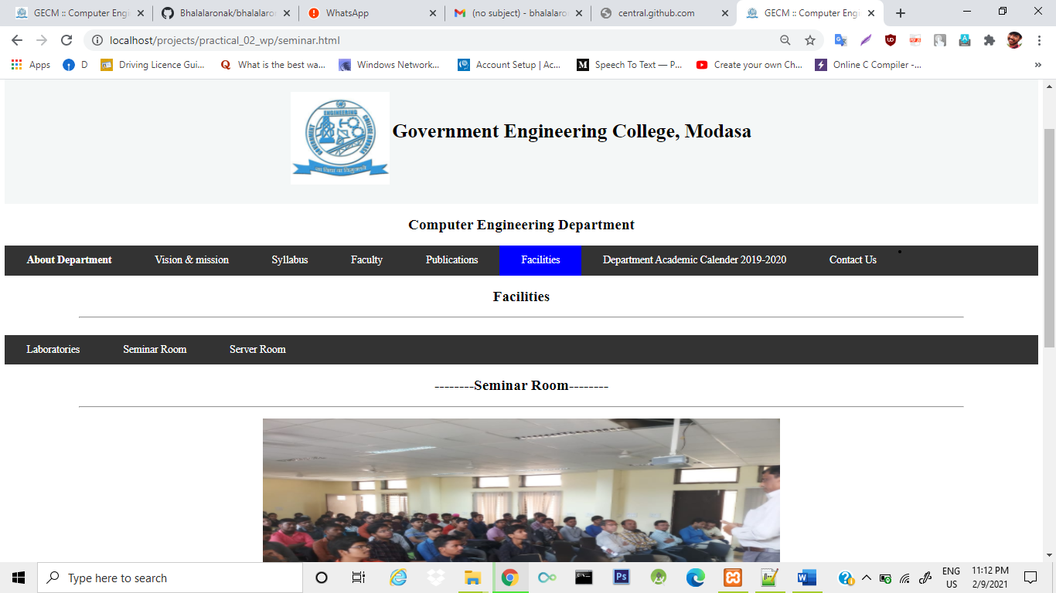

(Figure :- 1.4.1 Seminar page)

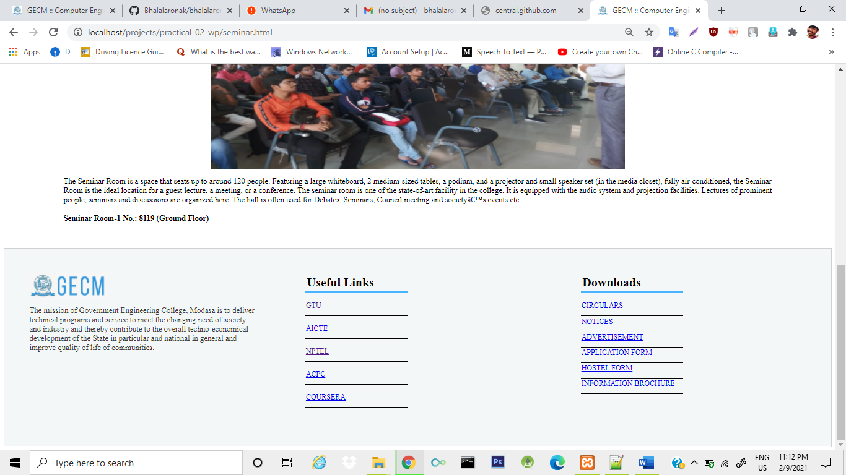

(Figure :- 1.4.2 Seminar page)

**server.html**

# <html>

# <head>

# <meta name="viewport" content="width=device-width, initial-scale=1.0">

# <title>GECM :: Computer Engineering</title>

# <link rel="shortcut icon" href="image\collegelogo.jpg">

# <link rel="stylesheet" type="text/css" href="main.css">

# </head>

# <body>

# <header>

# <center>

# <!--img src="image\department.jpeg"-->

# <br><br><br><br><br><br>

# <table > <tr><td><img src="image\collegelogo.jpg"></td><td>

# <h1>Government Engineering College, Modasa</h1></td></tr></table></center></header><center>

# <h2>Computer Engineering Department</h3></center>

# <section><nav class="topnav"><ul class="navto">

# <li><a href="indexmain.html"><b>About Department</b></a></li>

# <li><a href="visionandmission.html">Vision & mission</a></li>

# <li><a href="http://syllabus.gtu.ac.in/">Syllabus</a></li>

# <li><a href="faculty.html">Faculty</a></li>

# <li><a href="C:\xampp\htdocs\gecm\index.html">Publications</a></li>

# <li><a class="active" href="C:\xampp\htdocs\gecm\facilities.html">Facilities</a></li>

# <li><a href="C:\xampp\htdocs\gecm\index.html">Department Academic Calender 2019-2020</a></li></ul>

# <li><a href="faculty1.html">Contact Us</a></li></nav></nav>

# <h1><center>Facilities</center></h1>

# <hr style=" margin-left:120px; margin-right:120px;color:green;"><br><br>

# </section>

# <div class="navbar1">

# <div class="slab1 topnav" >

# <ul>

# <li><a href="facilities.html" class="navto">Laboratories</a></li>

# <li><a href="seminar.html">Seminar Room</a></li>

# <li class="active"><a href="server.html">Server Room</a></li>

# </ul>

# </div>

# <div>

# <h2><center><b>--------Server Room--------</b></h2></center>

# 

# 

# <hr style=" margin-left:120px; margin-right:120px;color:green;">

# <center><img src="image\server_room.bmp" class="style"></center>

# <p style="margin-left:120px; margin-right:120px;">The department maintains campus wide networking and INTERNET facility of institute. The INTERNET line is provided by NKN (National Knowledge Network) with speed up to 100 MBPS. Server room contains two high end servers, routers, Fortinet firewall system, switches and Wi-Fi controller.

# <br><br><b>Server Room No.: 8103 (Ground Floor)</b></p>

# </div>

# <div class="footer1">

# <div class="footer-content">

# <div class="footer-section about">

# <img style="height: 50px;" src="image\logo-footer.png">

# <p>The mission of Government Engineering College, Modasa is to deliver technical programs and service to meet the changing need of society and industry and thereby contribute to the overall techno-economical development of the State in particular and national in general and improve quality of life of communities.</p>

# </div>

# <div class="footer-section links">

# <table >

# <th class="footer-table" align="left">Useful Links</th>

# <tr ><td class="td2"><a href="https://www.gtu.ac.in/">GTU</a></td></tr>

# <tr ><td class="td2"><a href="https://www.aicte-india.org">AICTE</a></td></tr>

# <tr ><td class="td2"><a href="https://nptel.ac.in/">NPTEL</a></td></tr>

# <tr ><td class="td2"><a href="https://www.jacpcldce.ac.in/">ACPC</a></td></tr>

# <tr ><td class="td2"><a href="https://www.coursera.org/">COURSERA</a></td></tr>

# </table>

# </div>

# <div class="footer-section downloads">

# <table>

# <th class="footer-table" align="left">Downloads</th>

# <tr>

# <td class="td2"><a href="#">CIRCULARS</a> </td>

# <tr>

# </tr>

# <td class="td3"><a href="#">NOTICES</a></td>

# <tr>

# <td class="td3"><a href="#">ADVERTISEMENT</a></td>

# </tr>

# <tr>

# <td class="td3"><a href="#">APPLICATION FORM</a></td>

# </tr>

# <tr>

# <td class="td3"><a href="#">HOSTEL FORM</a> </td>

# </tr>

# <tr>

# <td class="td3"><a href="#">INFORMATION BROCHURE</a></td>

# </tr>

# </table>

# </div>

# </div>

# </div>

# </body>

# </html>

# OUTPUT:-

# 

(Figure :- 1.5.1 Sever page)

# 

(Figure :- 1.5.2 Server page)

# visionandmission.html

# <html>

# <head>

# <meta name="viewport" content="width=device-width, initial-scale=1.0">

# <title>GECM :: Computer Engineering</title>

# <link rel="shortcut icon" href="image\collegelogo.jpg">

# <link rel="stylesheet" type="text/css" href="main.css">

# <link href="https://maxcdn.bootstrapcdn.com/font-awesome/latest/css/font-awesome.min.css" rel="stylesheet">

# <!--link href="//netdna.bootstrapcdn.com/twitter-bootstrap/2.3.2/css/bootstrap-combined.no-icons.min.css" rel="stylesheet"-->

# <link href="//netdna.bootstrapcdn.com/font-awesome/3.2.1/css/font-awesome.css" rel="stylesheet">

# <link rel="stylesheet" href="path/to/bootstrap/css/bootstrap.min.css">

# <link rel="stylesheet" href="path/to/font-awesome/css/font-awesome.min.css"-->

# </head>

# <body>

# <header>

# <center>

# <!--img src="image\department.jpeg"-->

# <br><br><br><br><br><br>

# <table > <tr><td><img src="image\collegelogo.jpg"></td><td>

# <h1>Government Engineering College, Modasa</h1></td></tr></table></center></header><center>

# <h2>Computer Engineering Department</h3></center>

# <section><nav class="topnav"><ul class="navto">

# <li><a href="indexmain.html"><b>About Department</b></a></li>

# <li><a class="active" href="visionandmission.html" >Vision And Mission</a></li>

# <li><a href="http://syllabus.gtu.ac.in/">Syllabus</a></li>

# <li><a href="faculty.html">Faculty</a></li>

# <li><a href="C:\xampp\htdocs\gecm\index.html">Publications</a></li>

# <li><a href="facilities.html">Facilities</a></li>

# <li><a href="C:\xampp\htdocs\gecm\index.html">Department Academic Calender 2019-2020</a></li></ul>

# <li><a href="faculty1.html">Contact Us</a></li></nav>

# <!-- Content start -->

# 

# <!--content-->

# <div class="full-container" style="margin-top:30px;">

# <!-- <img class="img-responsive" src="../../assets/data/departments/ce/ce-department.png" alt="Computer Engineering Department" style="width:100%;">-->

# <div class="heading heading-v4" align="justify" style="margin-top:10px;">

# <h2><center>--------Vision----------</center></h2>

# <hr style=" margin-left:120px; margin-right:120px;color:green;">

# <p style="margin-left:120px; margin-right:120px;"align="justify">To become a prominent department producing

# competent professionals with research, innovation and entrepreneurial skills, inculcating moral values and societal concerns.</p>

# <br>

# <h2><center>--------Mission----------</center></h2>

# <hr style=" margin-left:120px; margin-right:120px;color:green;">

# <p style="margin-left:120px; margin-right:120px;" align="justify">

# <ul>

# <p style="margin-left:120px; margin-right:120px;" >To create globally competent students having ability

# to design, develop and test world class software,

# keeping pace with the latest technological

# developments.</p>

# <p style="margin-left:120px; margin-right:120px;">Create facilities and expertise in advanced computer technology thereby promote research.</li>

# <p style="margin-left:120px; margin-right:120px;">Enhance Industry Institute Interaction programme to get acquainted with corporate culture.</li>

# <p style="margin-left:120px; margin-right:120px;">Induce moral , ethical values and spirit of social commitment.</li>

# </ul>

# </p>

# <br>

# 

# 

# <div class="panel-heading">

# <center> <h3 style="margin-left:120px; margin-right:10px;"><i class="fa fa-tasks"></i> Program Educational Objectives PEOs</h3> </div> </center>

# <hr style=" margin-left:120px; margin-right:10px;color:green;">

# <p style="margin-left:120px; margin-right:10px;"><strong>Graduates will</p></strong>

# 

# <div>

# <table>

# 

# <table>

# <tr>

# <td ><strong><p style="margin-left:120px; margin-right:120px;">PEO1</p></td></strong>

# <td >Be an efficient Software developer in diverse fields and will be a successful professional and/or pursue higher studies. </p></td>

# </tr>

# <tr>

# <td ><strong><p style="margin-left:120px; margin-right:120px;">PEO2 </p></td></strong>

# <td >be capable to adapt advanced state of the art computing technology for professional excellence and Research and be a lifelong learner.</p></td>

# </tr>

# <tr>

# <td ><strong><p style="margin-left:120px; margin-right:120px;">PEO3</p></td></strong>

# <td >Work productively exhibiting ethical qualities for the betterment of society.</p></td>

# </tr>

# <tr>

# <td><strong><p style="margin-left:120px; margin-right:120px;">PEO4</p></td></strong>

# <td>Possess leadership and entrepreneurial qualities, work harmoniously as a team member with effective communication skills.</p></td>

# </tr>

# 

# </table>

# </div>

# </div>

# <!-- PSO start -->

# <br>

# <center> <h3 style=" margin-left:120px; margin-right:115px;"><i class="fa fa-tasks"></i> Program Specific Outcomes PSOs</h3> </div> </center>

# <hr style=" margin-left:120px; margin-right:120px;color:green;">

# <p style="margin-left:120px; margin-right:10px;"><strong>Computer Engineering Graduate will be able to:</p></strong>

# <br>

# <table >

# 

# <tbody>

# <center>

# <table>

# <tr>

# <td > <strong><p style="margin-left:120px; margin-right:120px;">PSO1</td></p></strong>

# <td > Gain capability to use current / advanced technology, skills and tools necessary for carrying out Real- World Multidisciplinary projects.</td>

# </tr>

# <tr>

# <td ><strong><p style="margin-left:120px; margin-right:120px;">PSO2</td></p></strong>

# <td >Achieve an ability to build a computer based system, process or a component that meets the desired needs.

# </td>

# </tr>

# <tr>

# <td><strong><p style="margin-left:120px; margin-right:120px;">PSO3</td></p></strong>

# <td > Apply concepts of core areas of Computer Engineering– Data Structures, Database Management Systems, Operating Systems, Computer Architecture and Software Engineering to provide innovative solution.

# </td>

# </tr>

# </tbody>

# </table>

# </table>

# </center>

# <!-- PSO end -->

# <!-- End Mech Labs -->

# </div>

# </div>

# <!-- End Content - <!--/container-->

# <!-- Content End -->

# <div class="footer1">

# <div class="footer-content">

# <div class="footer-section about">

# <img style="height: 50px;" src="image\logo-footer.png">

# <p>The mission of Government Engineering College, Modasa is to deliver technical programs and service to meet the changing need of society and industry and thereby contribute to the overall techno-economical development of the State in particular and national in general and improve quality of life of communities.</p>

# </div>

# <div class="footer-section links">

# <table >

# <th class="footer-table" align="left">Useful Links</th>

# <tr ><td class="td2"><a href="https://www.gtu.ac.in/">GTU </a></td></tr>

# <tr ><td class="td2"><a href="https://www.aicte-india.org">AICTE</a></td></tr>

# <tr ><td class="td2"><a href="https://nptel.ac.in/">NPTEL</a></td></tr>

# <tr ><td class="td2"><a href="https://www.jacpcldce.ac.in/">ACPC</a></td></tr>

# <tr ><td class="td2"><a href="https://www.coursera.org/">COURSERA</a></td></tr>

# </table>

# </div>

# <div class="footer-section downloads">

# <table>

# <th class="footer-table" align="left">Downloads</th>

# <tr>

# <td class="td2"><a href="#">CIRCULARS</a> </td>

# <tr>

# </tr>

# <td class="td3"><a href="#">NOTICES</a></td>

# <tr>

# <td class="td3"><a href="#">ADVERTISEMENT</a></td>

# </tr>

# <tr>

# <td class="td3"><a href="#">APPLICATION FORM</a></td>

# </tr>

# <tr>

# <td class="td3"><a href="#">HOSTEL FORM</a> </td>

# </tr>

# <tr>

# <td class="td3"><a href="#">INFORMATION BROCHURE</a></td>

# </tr>

# </table>

# </div>

# </div>

# </div>

# </body>

# </html>

# OUTPUT:-

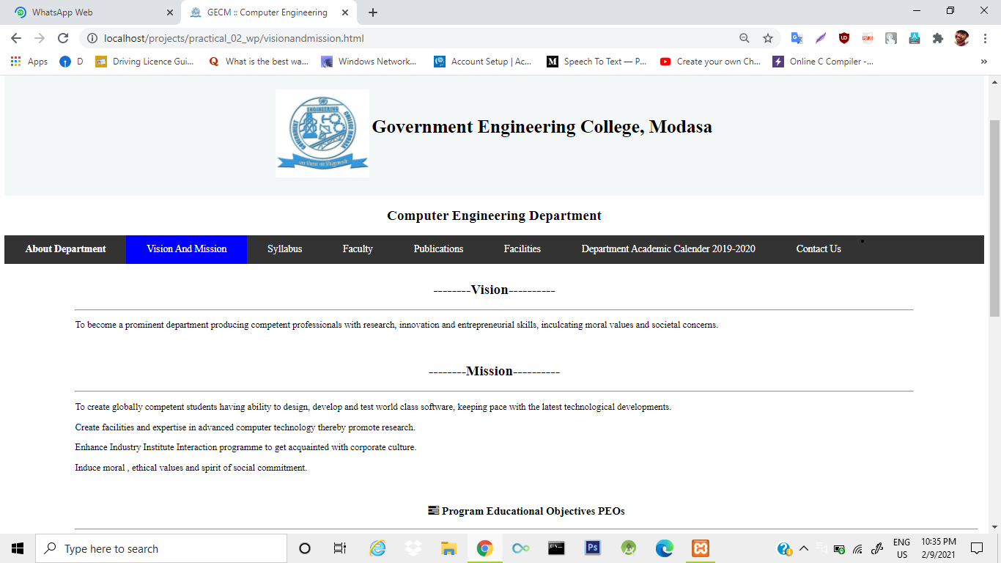

(Figure :- 1.6.1 vision and mission page)

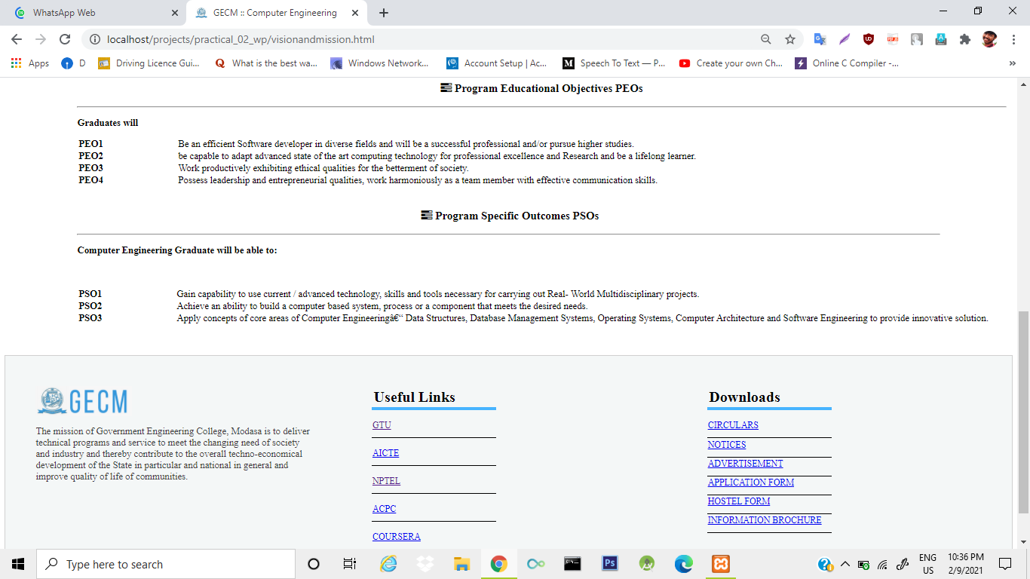

(Figure :- 1.6.2 vision and mission page)

# contactus.html

<html>

<head>

<meta name="viewport" content="width=device-width, initial-scale=1.0">

<title>GECM :: Computer Engineering</title>

<link rel="shortcut icon" href="image\collegelogo.jpg">

<link rel="stylesheet" type="text/css" href="main.css">

<link href="https://maxcdn.bootstrapcdn.com/font-awesome/latest/css/font-awesome.min.css" rel="stylesheet">

<!--link href="//netdna.bootstrapcdn.com/twitter-bootstrap/2.3.2/css/bootstrap-combined.no-icons.min.css" rel="stylesheet"-->

<link href="//netdna.bootstrapcdn.com/font-awesome/3.2.1/css/font-awesome.css" rel="stylesheet">

<link rel="stylesheet" href="path/to/bootstrap/css/bootstrap.min.css">

<link rel="stylesheet" href="path/to/font-awesome/css/font-awesome.min.css"-->

<style>

body {}

* {box-sizing: border-box;}

input[type=text], select, textarea {

width: 100%;

padding: 12px;

border: 1px solid #ccc;

border-radius: 4px;

box-sizing: border-box;

margin-top: 6px;

margin-bottom: 16px;

resize: vertical;

}

input[type=submit] {

background-color: #4CAF50;

color: white;

padding: 12px 20px;

border: none;

border-radius: 4px;

cursor: pointer;

}

input[type=submit]:hover {

background-color: lightpink;

}

.container {

border-radius: 5px;

background-color: #f2f2f2;

padding: 20px;

}

</style>

</head>

<body>

<header>

<center>

<!--img src="image\department.jpeg"-->

<br><br><br><br><br><br>

<table > <tr><td><img src="image\collegelogo.jpg"></td><td>

<h1>Government Engineering College, Modasa</h1></td></tr></table></center></header><center>

<h2>Computer Engineering Department</h3></center>

<section><nav class="topnav"><ul class="navto">

<li><a href="indexmain.html"><b>About Department</b></a></li>

<li><a href="visionandmission.html" >Vision & mission</a></li>

<li><a href="http://syllabus.gtu.ac.in/">Syllabus</a></li>

<li><a href="faculty.html">Faculty</a></li>

<li><a href="C:\xampp\htdocs\gecm\index.html">Publications</a></li>

<li><a href="facilities.html">Facilities</a></li>

<li><a href="indexmain.html">Department Academic Calender 2019-2020</a></li></ul>

<li><a class="active" href="faculty1.html">Contact Us</a></li>

</nav>

<h2><center>--------See location Here-------- </h2></center>

<br>

<hr style=" margin-left:120px; margin-right:210px;color:green;">

<br ><br>

<iframe style=" margin-left:120px; margin-right:120px;color:green;" src="https://www.google.com/maps/embed?pb=!1m18!1m12!1m3!1d3659.0851524866675!2d73.29814191432287!3d23.49344220446203!2m3!1f0!2f0!3f0!3m2!1i1024!2i768!4f13.1!3m3!1m2!1s0x395df194cdabd479%3A0xf669f2347bbb06cf!2sGovernment%20Engineering%20College%2C%20Modasa!5e0!3m2!1sen!2sin!4v1609520788629!5m2!1sen!2sin" width="80%" height="80%" frameborder="0" style="border:0; margin-top:10px;" allowfullscreen="" aria-hidden="false" tabindex="0"></iframe>

<div><form style=" margin-left:120px; margin-right:120px;">

<h2 align="center"> Contact Us Here .....! </h2>

<br>

<hr style="margin-left:120px; margin-right:120px;">

<br ><br>

<div class="container" style="width: 100%;

border: 1px solid #4CAF50; align="center">

<form action="/action_page.php">

<label for="fname">Name</label>

<input type="text" id="fname" name="firstname" placeholder="Your name..">

<label for="lname">E-Mail Address</label>

<input type="text" id="lname" name="lastname" placeholder="Enter Your E-Mail Address here..">

<!--label for="country">Country</label>

<select id="country" name="country">

<option value="australia">Australia</option>

<option value="canada">Canada</option>

<option value="usa">USA</option>

</select-->

<label for="subject">Subject</label>

<textarea id="subject" name="subject" placeholder="Write Message Here .." style="height:200px"></textarea>

<input type="submit" value="Submit">

</form>

</div>

</form>

<div class="col-md-3" align="center" style="margin-left:15px">

<!-- Contacts -->

<div class="headline" style="margin-top:15px;">

<h2>College Campus</h2>

<hr style=" margin-left:120px; margin-right:120px;color:green;">

</div>

<table>

<tr>

<ul class="list-unstyled who margin-bottom-30" align="justify">

<td><li><i class="fa fa-home"></i> &nbsp;&nbsp;&nbsp; Shamlaji Road, Modasa, District Aravalli , Gujarat, India 383315</li></td>

</tr>

<li><i class="fa fa-envelope"></i>&nbsp;&nbsp;&nbsp;<!--modasa_engg@yahoo.co.in--> gec-modasa-dte@gujarat.gov.in</li>

<li><i class="fa fa-phone"></i>&nbsp;&nbsp;&nbsp;(+91)02774 242 633/634</li>

<li><a href="https://www.gecmodasa.ac.in"><i class="fa fa-globe">&nbsp;&nbsp;&nbsp;</i>http://www.gecmodasa.ac.in</a></li>

</ul>

</table>

<!-- Working Hours -->

<div class="headline">

<h2>Working Hours</h2>

<hr style=" margin-left:120px; margin-right:120px;color:green;">

<br ><br>

</div>

<ul class="list-unstyled margin-bottom-30">

<li><strong>Monday-Friday:</strong> 10:30am to 6:10pm</li>

<li><strong>Saturday:</strong> 10:30am to 6:10pm (Closed on 2nd &amp; 4th)</li>

<li><strong>Sunday:</strong> Closed</li>

</ul>

<!-- Why we are? -->

<div class="headline">

<h2>Why we are?</h2>

<hr style=" margin-left:120px; margin-right:120px;color:green;">

<br ><br>

</div>

<p>The mission of Government Engineering College, Modasa is to deliver technical programs and service to meet the changing need of society and industry and thereby contribute to the overall techno-economical development of the State in particular and national in general and improve quality of life of communities.</p>

</div>

<!--/col-md-3-->

</div>

<!--/row-->

</div>

<!-- End Contact -->

<!-- End Content -->

</div>

</div>

<div class="footer1">

<div class="footer-content">

<div class="footer-section about">

<img style="height: 50px;" src="image\logo-footer.png">

<p>The mission of Government Engineering College, Modasa is to deliver technical programs and service to meet the changing need of society and industry and thereby contribute to the overall techno-economical development of the State in particular and national in general and improve quality of life of communities.</p>

</div>

<div class="footer-section links">

<table >

<th class="footer-table" align="left">Useful Links</th>

<tr ><td class="td2"><a href="https://www.gtu.ac.in/">GTU</a></td></tr>

<tr ><td class="td2"><a href="https://www.aicte-india.org">AICTE</a></td></tr>

<tr ><td class="td2"><a href="https://nptel.ac.in/">NPTEL</a></td></tr>

<tr ><td class="td2"><a href="https://www.jacpcldce.ac.in/">ACPC</a></td></tr>

<tr ><td class="td2"><a href="https://www.coursera.org/">COURSERA</a></td></tr>

</table>

</div>

<div class="footer-section downloads">

<table>

<th class="footer-table" align="left">Downloads</th>

<tr>

<td class="td2"><a href="#">CIRCULARS</a> </td>

<tr>

</tr>

<td class="td3"><a href="#">NOTICES</a></td>

<tr>

<td class="td3"><a href="#">ADVERTISEMENT</a></td>

</tr>

<tr>

<td class="td3"><a href="#">APPLICATION FORM</a></td>

</tr>

<tr>

<td class="td3"><a href="#">HOSTEL FORM</a> </td>

</tr>

<tr>

<td class="td3"><a href="#">INFORMATION BROCHURE</a></td>

</tr>

</table>

</div>

</div>

</div>

</body>

</html>

# OUTPUT:-

# 

# 

(Figure :- 1.7.1 contact us page)

# 

(Figure :- 1.7.2 contact us page)

# 

(Figure :- 1.7.3 contact us page)

# 

(Figure :- 1.7.4 contact us page)

# When we are clicking on syllabus it will redirect on gtu syllabus page

# OUTPUT:-

# 

(Figure :- 1.8.1 syllabus page)